Team ID : PNT2022TMID04418

Setting up Application Environment

Create IBM Cloud Account

Step1: Navigate to ibm academic and register with your smartiternzmail
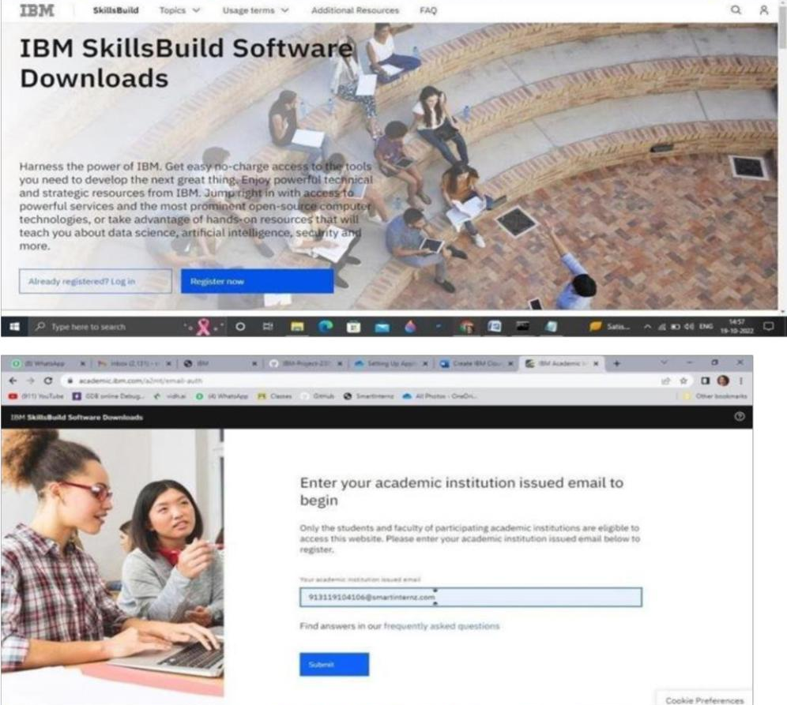

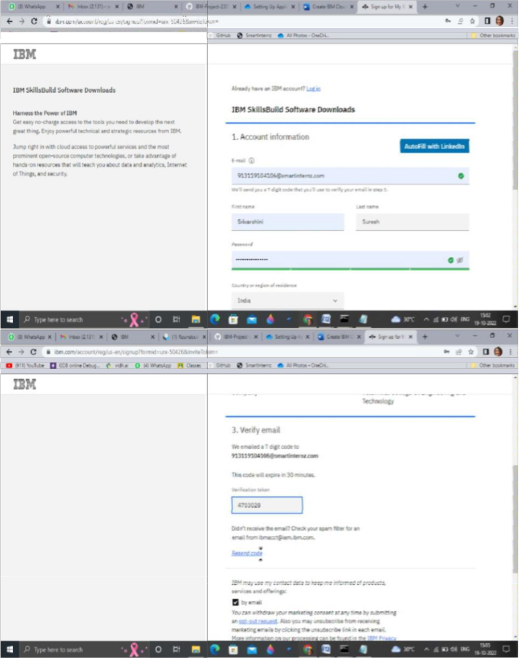

Step 2: Now go to cloud.ibm.com and login with your registered mail id along with coupon code obtained from ibm.com/academic

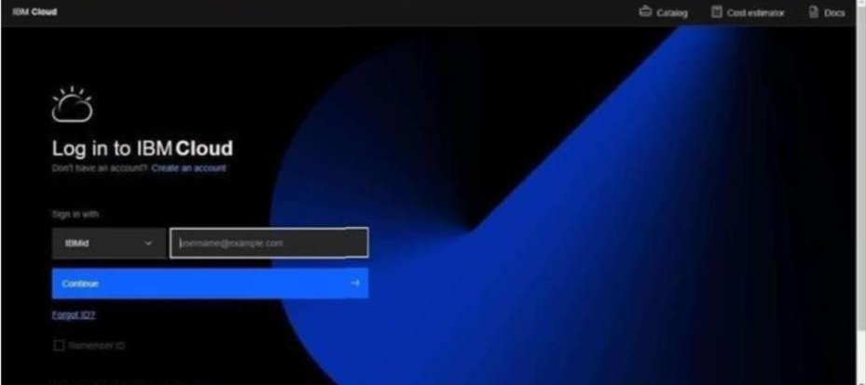

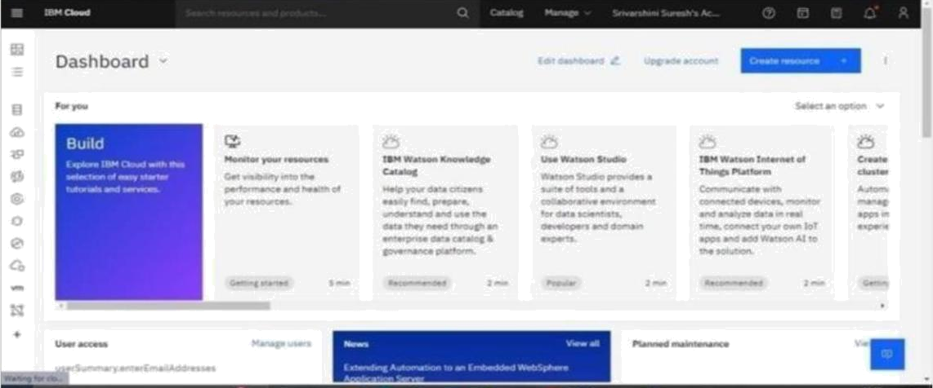

Output : Cloud account created successfully.

